USING TEMPLATES

Basic templates have been created in WorkFlows, if you would like to use them when adding new titles into the catalog.

**RECOMMENDED – Use the templates to create your own library’s template. Duplicate and rename the generic template with your own library three letter code in the title. For example – duplicate and rename the TEMPLATE LARGE TYPE to INS TEMPLATE LARGE TYPE. Then add any other relevant information for your library.**

1. In the title Wizard choose DUPLICATE TITLE

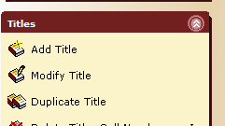

**NOTE : Don’t forget to set up your properties by right clicking on your wizard. Your NEW duplicated title call number and item information will reflect whatever is in your defaults.**

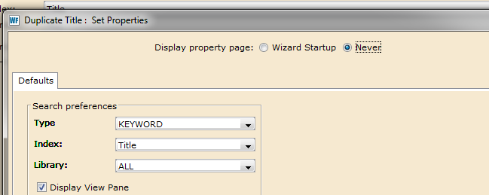

1. Search for the word TEMPLATE in TITLE INDEX (not General) and either scroll toward the bottom of the list, or re-sort by publication year. Or search by the exact title.

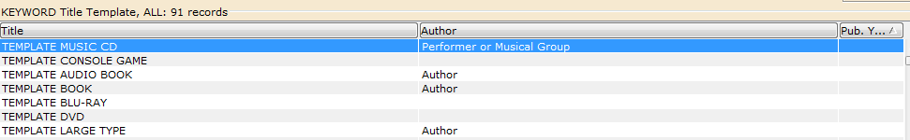

1. Choose the template you want to use and open it, either by double clicking on the title, or choosing the Duplicate Tab at the bottom of your screen. **You are now adding your new title.**

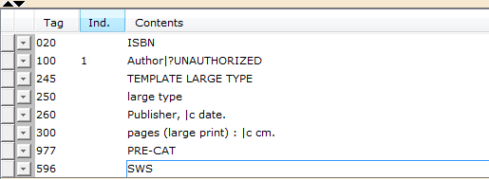

1. Type in your NEW information. Place your curser at the beginning of each text box. Type over or erase the template information. Add other fields if required by your library.

**PLEASE NOTE** : The delimited fields can be typed over, so you may have to put them back in.

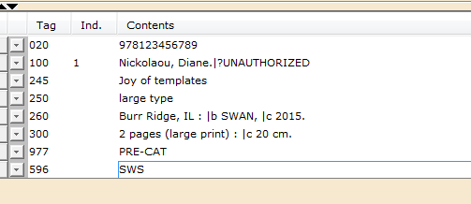

1. Tab over to the CALL NUMBER /ITEM tab and enter the item information as required by your library.

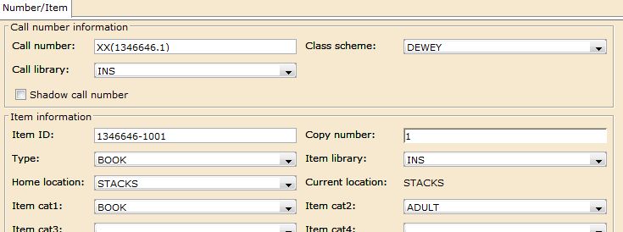

1. Save and Close.