**Running Reports and Formatting the Document in Excel**

* 2 types of reports – count the items, and list the items. (Count reports will ONLY count, List reports will list titles).
* In the REPORT SESSION WIZARD, add a path in the APPLICATION TO VIEW XML REPORTS. (It might look like something like this.. C:\Program Files\Microsoft Office\Office14\EXCEL.EXE ) Check with your IT department if you are not sure. OK

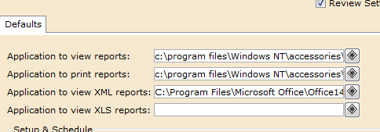

* SCHEDULE NEW REPORTS WIZARD
* Find the Templates Tab. Choose the report you want to run, depending on your criteria.
* SET UP AND SCHEDULE
* In the Item Selection Tab choose your criteria.

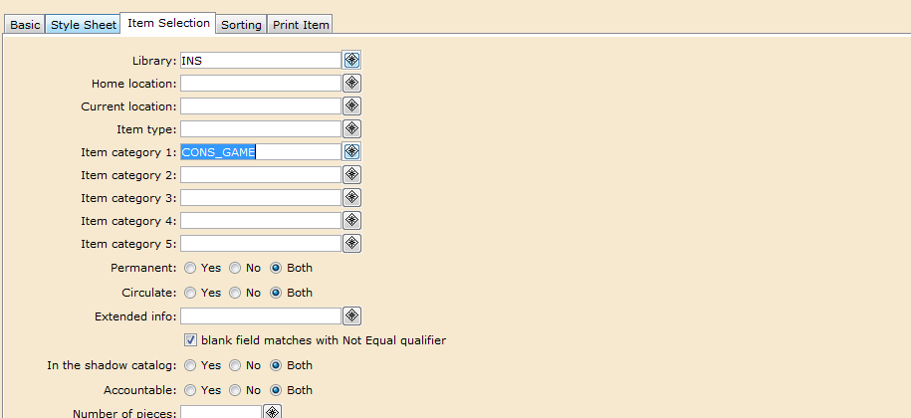

* In the Print Item Tab choose the XML radio button.
* With this type of formatting, only one MARC field is available. Recommended is the title field, 245. (You can choose more than one field in the Entry list.. but in Excel it will put the fields on separate lines, so you won’t be able to sort. You can play around with what works best for you.)
* Choose the level of Call number and Item information you want to export. (See the document called Reports – Print Item Options to see what fields each choice will report.)

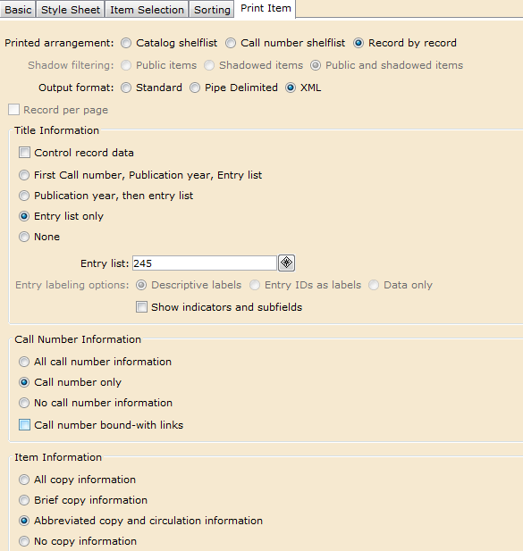

* RUN NOW
* Close the next window or VIEW FINISHED REPORTS.
* NOTE : You should be able to see your report in the Scheduled Reports wizard if it is a big report and is taking a while to complete.
* NOTE : You may have to wait for another report to finish before yours is run. Please schedule your big reports to run at less busy times. Smaller reports should pop up in just a few minutes if no other report is running.
* Click on FINISHED REPORTS. When your report is ready you will see it listed. (To refresh the list, choose the “Bunny Ears”.



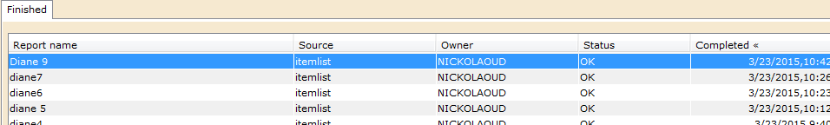

* Click on your finished report.
* Uncheck the VIEW LOG and FORMAT REPORT buttons. OK

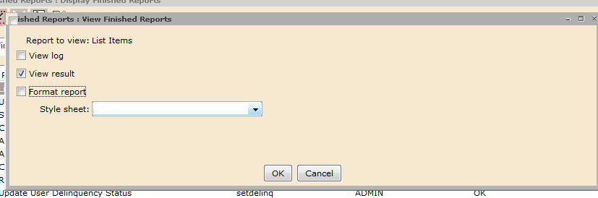

* It is ready to open in Excel. Choose the USE THE XML SOURCE TASK PANE button.

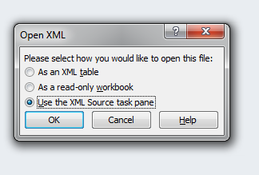

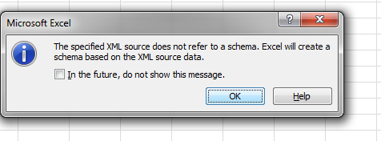

* OK.
* NOTE: If you ONLY see Report (Title, Date Created, Date Format) it means your search did not find any matching criteria

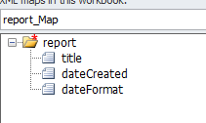

* **Along the right hand side in Excel you should see something like this.**

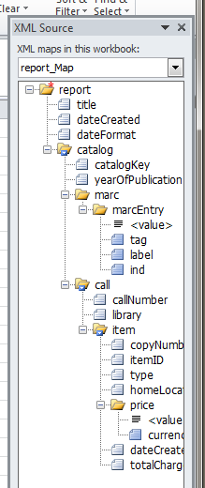

* Click on and drag the fields you want displayed into the top row of your excel document.

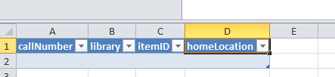

* To see your 245 field (or whatever field you chose) click and drag the = <value> field.

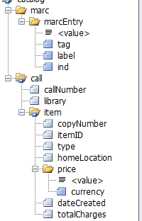

* NOTE : If you accidently close this this XML Source box, and want to add another field to your document, just right click in your document, go down to XML, and choose XML Source from the next menu box.

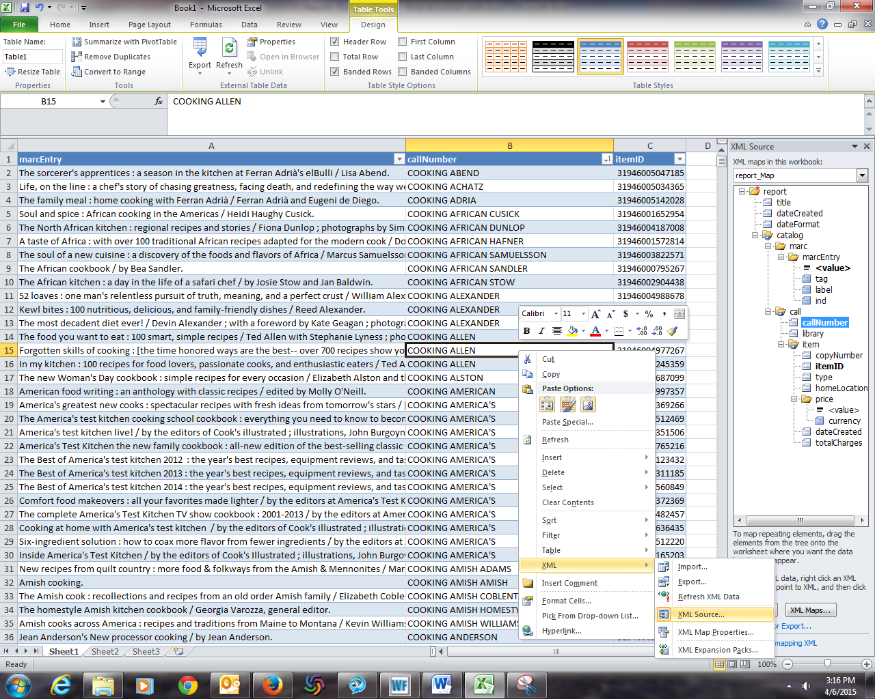

* **At the top of the Excel document the TABLE TOOLS should be highlighted. Click on “REFRESH”**

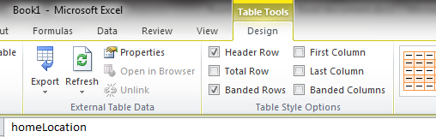

* This will populate your columns with your data.
* If you need to format your barcode numbers, right click and choose FORMAT CELLS.
* Choose number, and move your decimal spaces to 0.

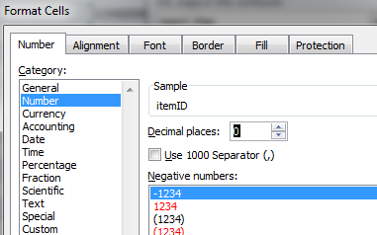

* Your finished report should look like this.

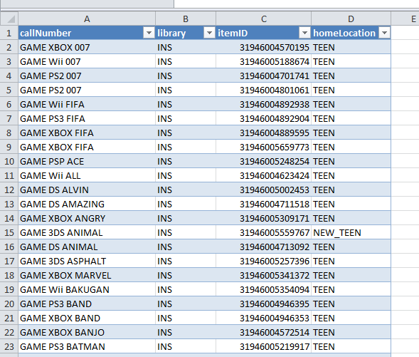

* To sort columns click on the drop down arrow at the top of the column and sort A to Z.
* TO PRINT : Go to Page Layout and choose your page Orientation (Portrait or Landscape)
* Make sure your Gridlines - View is checked.

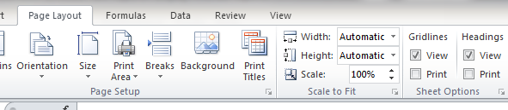

* You should see the dotted line that shows where your page break is.

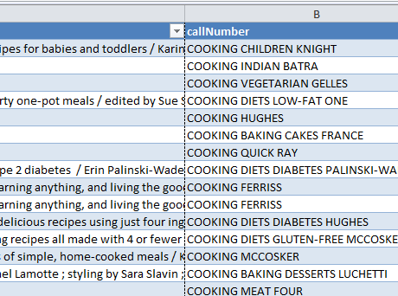

* Adjust your column widths to be to the left of that line.

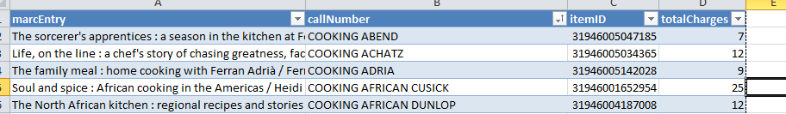

* File
* Print