**SWAN Symphony WorkFlows: Creating A Pre-Cat (Brief Bibliographic Record)**

When there is no bibliographic record that matches your item in WorkFlows:

1. Go to the **Cataloging module**.
2. Open the **Titles** group on the left side of the screen.
3. Open the **Add Title Wizard**.
4. The default should be set to BRIEF Entries Template and will automatically display this brief template for you. This can be changed if needed by right clicking on the wizard and choosing Properties.

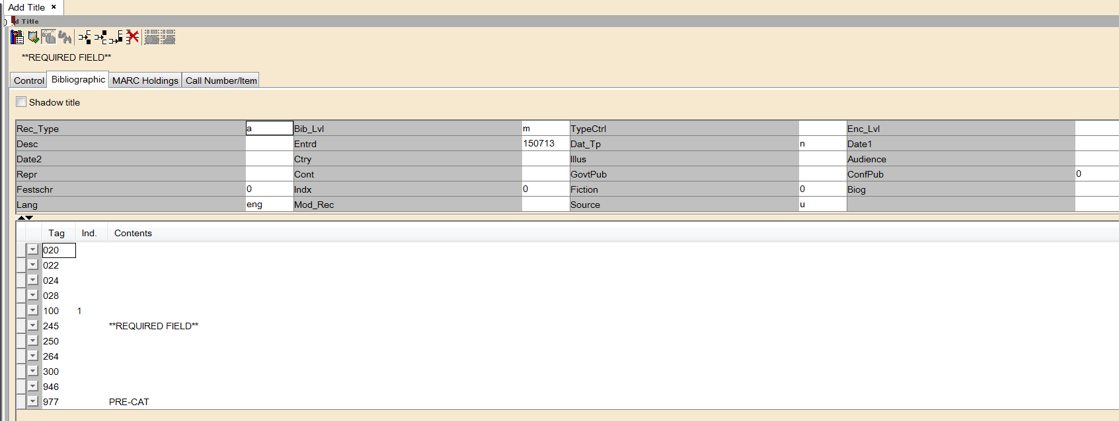

1. On the Bibliographic tab, fill in the following information under “Contents”:
2. ISBN (020): Enter the 10-digit and the 13-digit ISBN. Do not use hyphens or spaces.

Example: 1447261062 and 9781447261063.

b. Author (100): Last name, First name.

c. Title (245): *Required* for all brief record entries. Delete the auto-generated “Required Field”

text. Type the title exactly as it appears on your item. Always include initial articles such as A, An, The. You will need to include 2 indicators. These indicators are directly after the 245. You can either tab over to, or move your mouse to, the field directly after the 245. The first indicator will always be a 0. The second indicator will be a skip indicator. You will need to include a skip indicator for words such as: **a, an, the.** Example: The old man and the sea. Skip indicators for the word “the” would be 4, (3 for the word “**the**” and one space for after “**the**”).

Please include these identifying numbers if they apply:

020=ISBN number

022=ISSN number

024=Standard number/UPC number

028=Manufacturer’s number

d. Other title (246): Omit initial articles such **as *a, an, the***.

e. Edition (250): use to identify large print, abridged, blu-ray, etc.

e. Publication information (264): Publisher, date.

Note: it is very important to include subfield “c” with a date.

f. Physical description (300): Pages, videodiscs, dimensions

g. Series (490): If applicable

h. Note (500): If applicable

i. Additional author (700): Last name, First name.

j. (946): library code/staff initials/date (ex. sws/kb/022715)

1. Go to the tab at the top of the screen that is labeled **Call Number/Item**.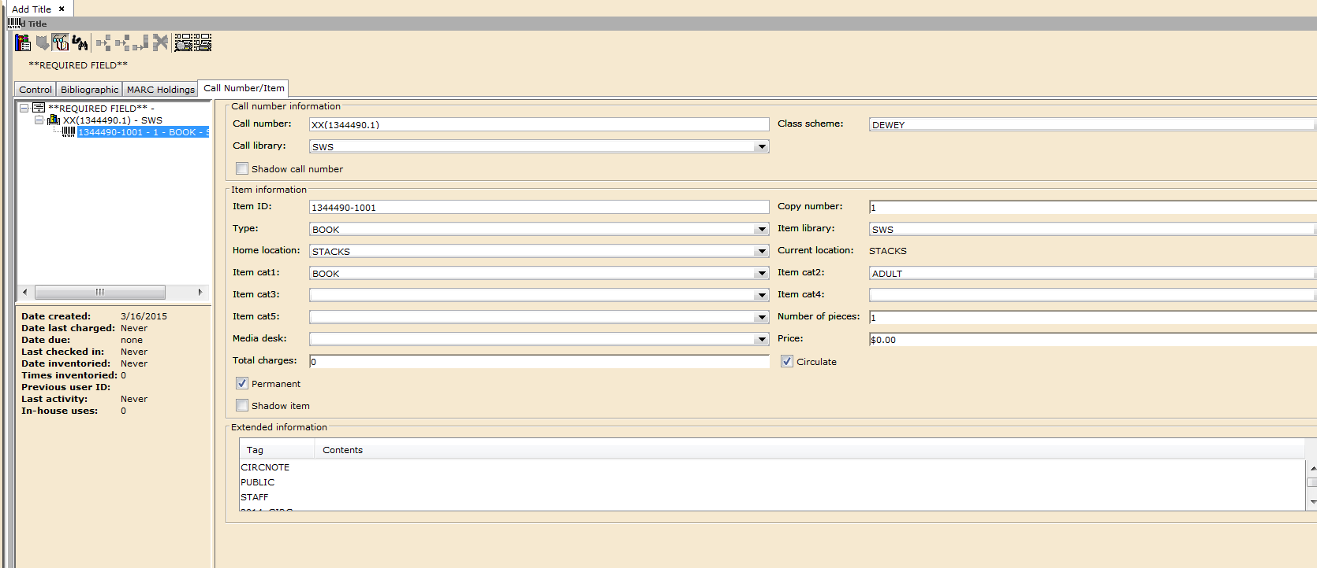

**Please verify the item information for accuracy, confirming Type, Library, Item Category 1 and Item Category 2. Note that Item Category 1 and Item Category 2 are required.**

1. A system call number will be automatically generated. You will replace this later with the actual **Call Number**.
2. **Class scheme:** DEWEY will display as default for your library unless you use LC.
3. **Call library:** Your library’s WorkFlows code should display as default.
4. **Shadow call number:** Default is for this box to be unchecked.
5. **Item ID** will be auto generated. You will replace this later with the actual barcode.
6. **Copy number:** This number is automatically generated by WorkFlows.
   * + 1. Please do not edit this number.
7. **Type:** Select the item type code that matches your item’s format.
   * 1. Example item types: BOOK, CD-AUDIO, DVD
     2. Item type determines circulation and hold rules.
     3. Assigning an item type to each item cataloged is required.
8. **Item library:** Your library’s WorkFlows code
9. **Home location:** Select a home location code that indicates where the item is shelved in your
   1. library. Example home locations: STACKS, NONFICTION, REFERENCE. Assigning a home location to each item cataloged is required.
10. **Current location:** The current status of the item. This value cannot be edited during this process.
11. **Item cat 1:** Select from the list of formats, depending on the item.
    1. Assigning an item cat 1 to each item cataloged is required.
12. **Item cat 2:** Select the code that represents the item’s audience level.
    1. ADULT, JUVENILE or TEEN.
    2. Assigning an item cat 2 to each item cataloged is required.
    3. UNKNOWN must be in the item cat 2 menu, but it should not be assigned to items.
13. **Number of pieces:** Libraries can decide if they want to leave the number of pieces field in the item record at default of 1 or change to reflect actual number of pieces. Each piece will count as an item circulated.
14. **Media desk:** Leave this box blank.
15. **Price:** Enter the replacement cost for the item.
16. **Total charges:** This number is automatically generated by WorkFlows. Please do not edit this number.
17. **Circulate:** This box should be checked and is set as default.
18. **Permanent:** This box should be checked and is set as default.
19. **Shadow item:** Default is for this box to be unchecked.
20. **Extended information:** Enter additional information about the item. Use of the extended

information notes is optional.

CIRCNOTE: This note will appear as a pop-up in WorkFlows when the item is checked out and when it is checked in.

Example circ notes:

Please make sure power cord is included.

Please check for 6 discs.

PUBLIC: A public note is ***visible*** to patrons and can provide important information about the item.

Example public notes:

Please visit the Adult Services Desk to check out the iPad.

STAFF: This note only appears when the item record is viewed in WorkFlows. The note

is intended for staff purposes only.

Example staff notes: Laptop protective case scratched -- 9/18/14

11. Click the **Save** button at the bottom.

Your library’s item will appear first in the title / call number / item tree on the left side of the Call Number/Item screen.

**Following are samples of Pre-Cat records:**

**DVD PRE-CAT**

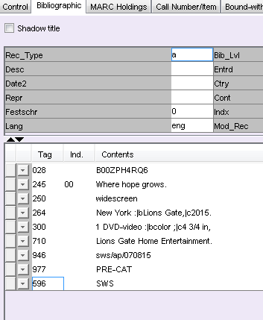

**BLU-RAY PRE-CAT**

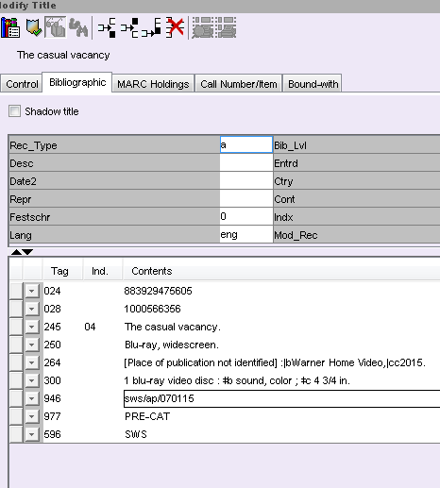

**BOOK PRE-CAT**

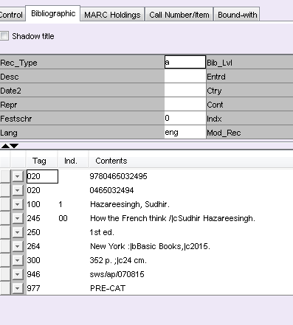

**CD PRE-CAT**

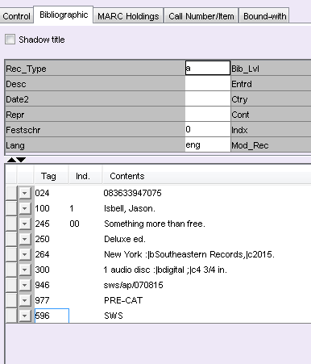

**Console Game Nintendo 3DS**

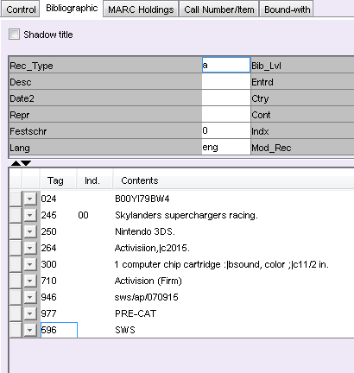

**LARGE PRINT PRE-CAT**

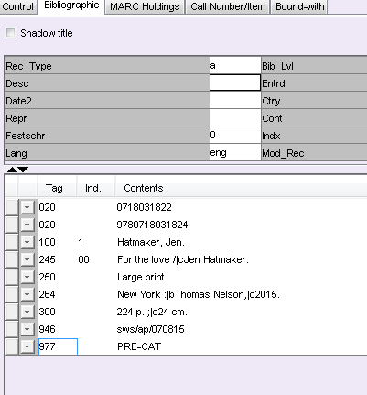

**PLAYAWAY AUDIO PRE-CAT**

