**WorkFlows updates for Technical Services staff May 1, 2015**

**On-Order dummy item records**

If your individual library work flow includes creating “dummy on-order item records” you will need to use a Class Scheme of ONORDER in conjunction with the XX Call Number. This will generate the substitution text of ONORDER for the Call number in Enterprise. *Please note that you will need to change Class Scheme back to Dewey when you catalog the item and create a call number.*

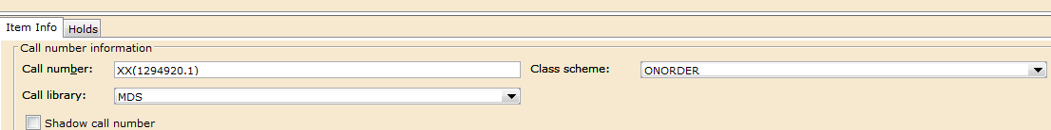

You may set this up in Properties for the following wizards:

* Call Number and Item Maintenance
* Add Title
* Duplicate Title

Example:

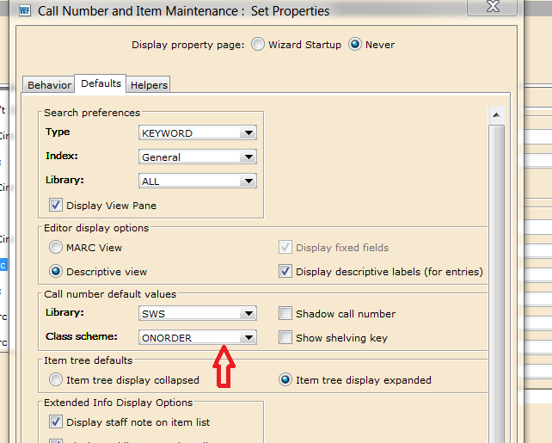

Note: we are working with SirsiDynix to determine if they can make a global change to the existing XX Call Numbers.

**ONORDER Users**

We are now able to create individual ONORDER users for each library as needed. If your library uses ONORDER User in your work flow and you would like an individual user created, please send an email to [help@swanlibraries.net](mailto:help@swanlibraries.net) to open a ticket using the subject: ONORDER User.

**Searching in WorkFlows**

**Exact Title Search**

Titles do not display in an exact search when it does not match the exact heading. An example is a title such as "All the light we cannot see" that has "a novel" (located in the |b subfield) as part of the *exact* heading. You need to search for "All the light we cannot see a novel" to bring these records up with an exact search.  
  
You may want to use a browse or keyword search instead to bring up all the records.

**ISBN Search**

ISBN searching in WorkFlows can be performed using General index-Keyword search or Standard Number index-Keyword search. ISBN searching will not convert a 10 digit ISBN to a 13 digit ISBN and vice-versa so you will only retrieve a match if the exact ISBN is included in the record. It is important to note that one should include both 10 digit and 13 digit numbers, if available, when creating Pre-cats.

**Item information drop-down menus**

You have a variety of options when you are creating new item records. For example, locations and item types customized for your library are available using the drop-down menus so be sure to change these and other item information from the default as appropriate.

**Bibliographic record merges**

Please continue to submit these requests to SWAN Bibliographic Services staff using the web forms on the SWAN Support site. Please be aware that there may be a delay in merging records as we are not able to merge any records that have an INTRANSIT item attached.

**Batch item deletions**

The DISCARD Process ran successfully on 5/1/15 with a few exceptions. Items with holds, under serial control or attached to a title with existing orders could not be deleted. We will work on developing best practices for dealing with these items moving forward.

**Global Item Edits**

SWAN is not able to perform any batch editing yet due to the ongoing mass record edits that continue to be processed by SirsiDynix. If you have any batch edit requests please send an email to [help@swanlibraries.net](mailto:help@swanlibraries.net) to open a ticket using the subject: Global Item Edit Request and include details of your request. Requests will be added to our queue and processed as soon as possible once SWAN staff are able to use Item Group Editor.

**Current Location AVAILABLE_SOON**

We are able to customize your cataloging wizards to set Current Location of new items to AVAILABLE_SOON. This is only recommended if you create items at time of receipt. The item will be removed from this location when it is checked in or checked out to a different user. If you are interested in this customization of your cataloging wizards, please send an email to [help@swanlibraries.net](mailto:help@swanlibraries.net) to open a ticket using the subject: AVAILABLE_SOON.

When this is customized, the option for auto-generated Item ID will also be turned off unless you specify otherwise.