Offline Circulation Settings

In preparation for the downtime this weekend, please check your Offline Session Settings today in WorkFlows.

* Click on the Offline tab in WorkFlows and select “Offline Session” under Common Tasks.
* Make certain in Defaults that you have your user access set to OFFLINE and you have your library selected.

We have had some libraries reporting their delinquent list file is out of date. Above the checkbox on the right “Use user delinquent list file” you should see today’s date.

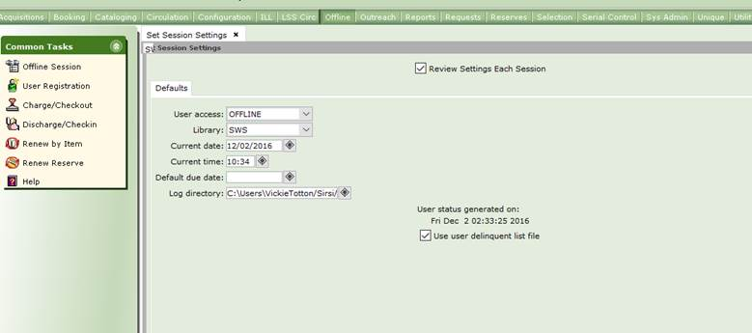

If today’s date is not displayed, please uninstall and reinstall the WorkFlows client then check your settings again. Follow this link for the installation instructions. You will have to log in to access the instructions. <https://support.swanlibraries.net/system/files/SWANTech/Software%20Downloads/WorkflowsInstallationGuide_3.5.1.1.pdf>.

**You have to do this today in order to download the most recent delinquent file as you won’t be able to connect to get the file tomorrow**. If you are unable to reinstall the client today, you will still be able to circulate in Offline tomorrow, but you will have to uncheck the “Use user delinquent list file” box.

If you should need any assistance, please open a ticket immediately at [help@swanlibraries.net](mailto:help@swanlibraries.net)